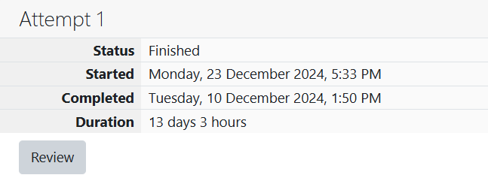

ROLL NO.:241801281

NAME: SUJITHA NEELAKANDAN VIGNESHWARI

WEEK 05-02 PRACTICE SESSION:

1. OBJECTIVE:

The k-digit number N is an Armstrong number if and only if the k-th power of each digit sums to N. Given a positive integer N, return true if and only if it is an Armstrong number.

CODE:

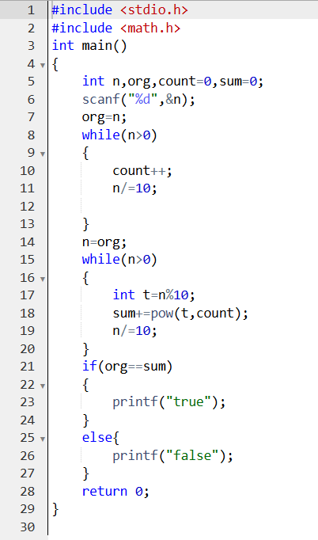

OUTPUT:

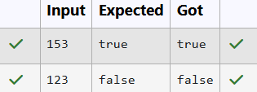

2.OBJECTIVE:

Take a number, reverse it and add it to the original number until the obtained number is a palindrome. Constraints 1<=num<=99999999 Sample Input 1 32 Sample Output 1 55 Sample Input 2 789 Sample Output 2 66066

CODE:

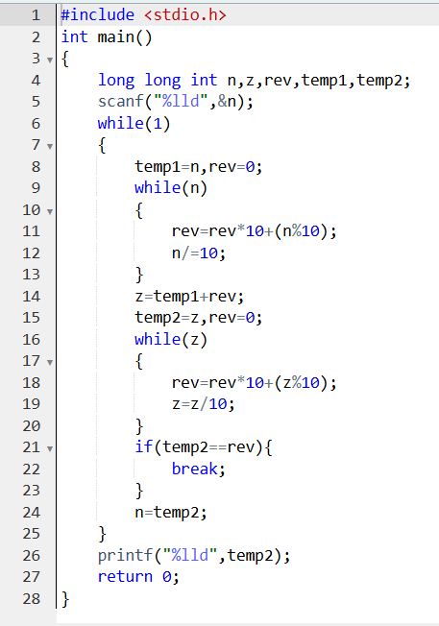

OUTPUT:

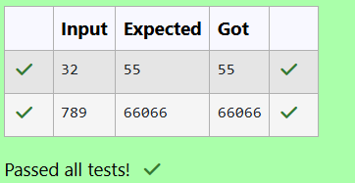

3.OBJECTIVE:

The program should accept a number 'n' as input and display the nth lucky number as output.

CODE:

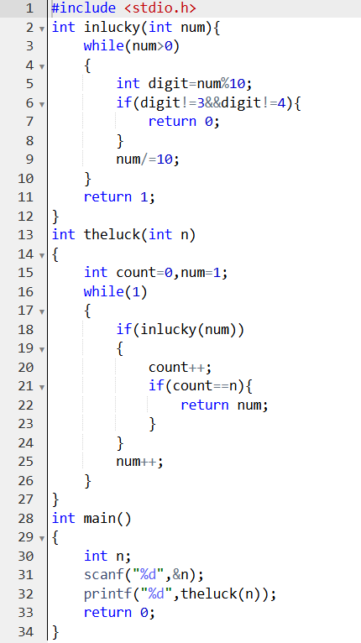

OUTPUT:

